**Media Assets Center: Router Button Locations**

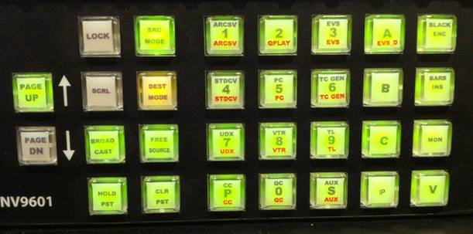

**1 – ARCSV –** Quantel Ports (ARCSV04, Port 5 is 1-4-5)

**2 – QPLAY** –

**3 – EVS** – EVS Servers (Server 3-1 is 3-3-1)

**4 – STDCV** – SD Standards Converters (STDCV 1-4, Alchemist (STDCV 7 -8) and Frame Rate Converter (STDCV 10)

**5 – PC** – Mac Pro (Mac 4 is 5-4)

**6 – TC GEN** - Time Code Generators (TC GEN 2 is 6-2)

**7 – UDX** – Up Down Cross Converters (UDXC 6 is 7-6)

**8 – VTR** – all decks (VTR 1254 is 8-1-2-5-4)

**9 – TL** – Tie-lines (TL 12 is 9-1-2)

**0 – QC** – QC Stations (QC 1-8, QC 108, QC 120, QC 132)

**S – AUX** – SD Decks (ex. VTR1254S)

**BLACK**

                HD BLK – BLACK_1

                NTSC BLK – BLACK_S

                SD PAL BLK – BLACK_SP

HD PAL BLK – BLACK_P

**BARS**

                HD BARS – BARS_1

                NTSC BARS – BARS_S

                SD PAL BARS – BARS_SP

HD PAL BARS – BARS_P

**BROADCAST** – used when using the Universal VTR Controller for more than 1 deck at

**Note for SD Decks**

When punching up a SD deck, you will need to press **S-Aux** after the VTR number. (ex. VTR1091**S**)